**Introduction:**

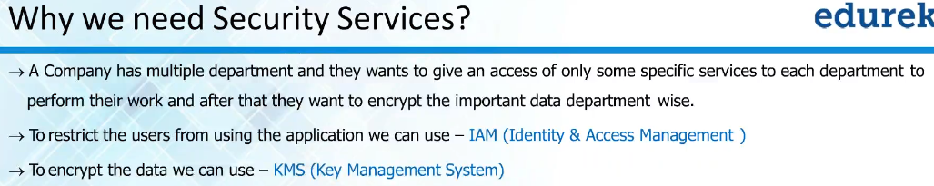

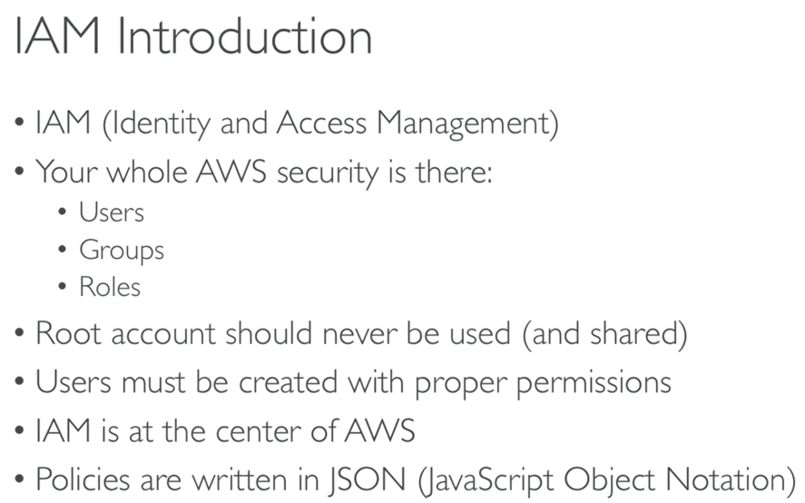

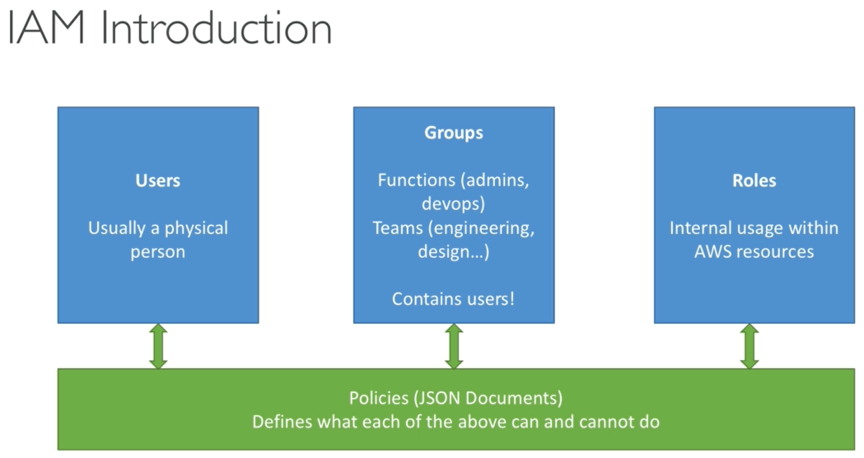

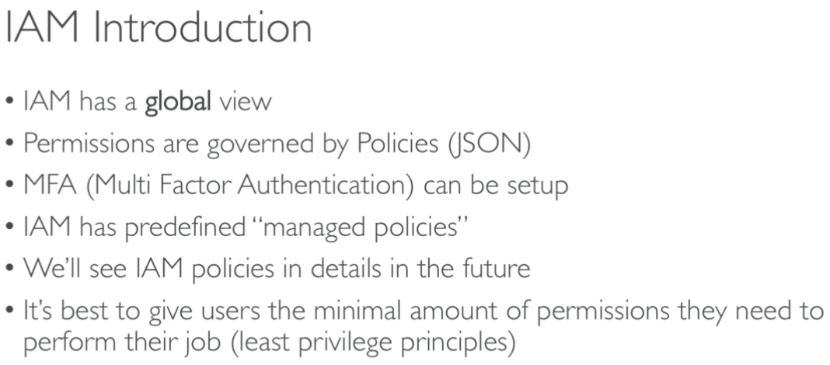

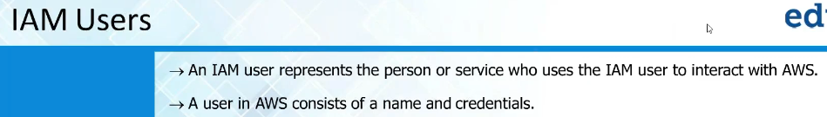

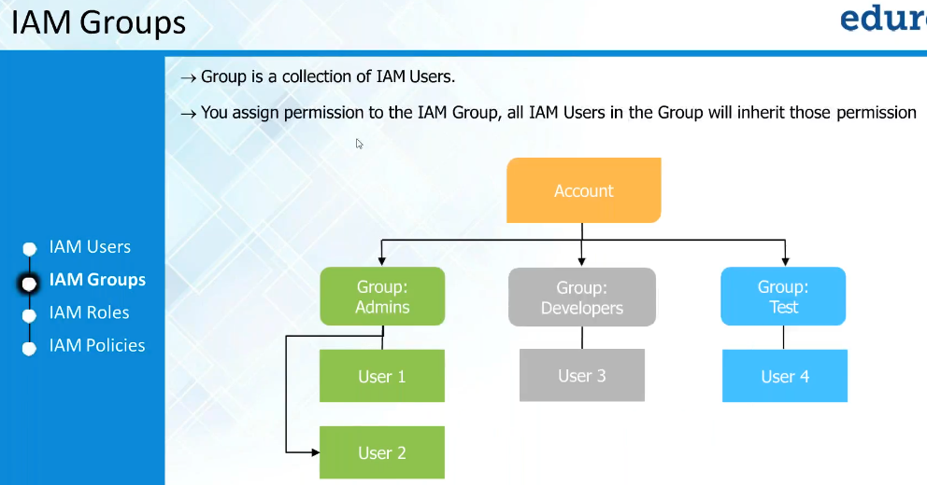

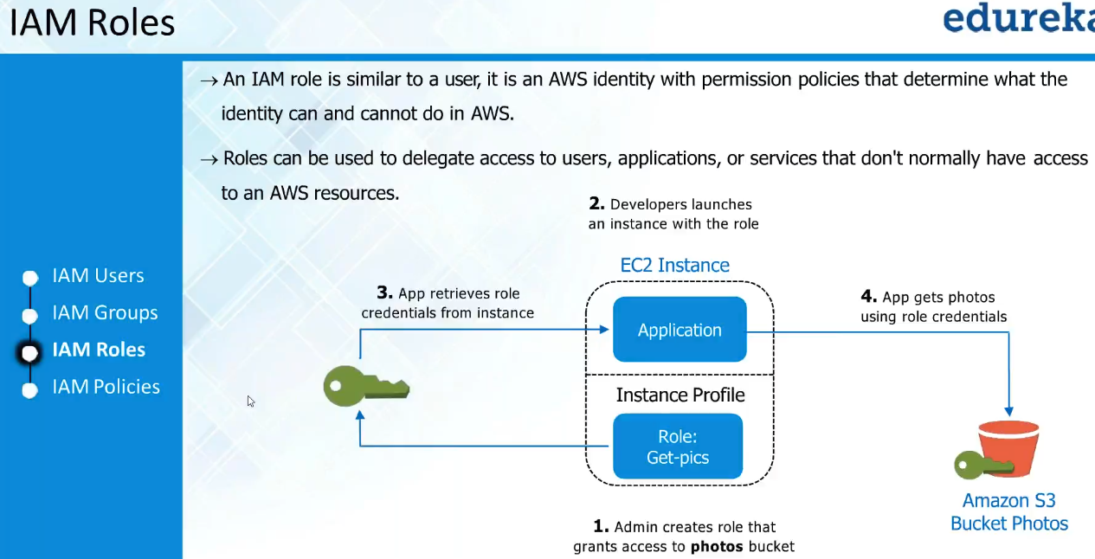

* We give roles on services
* So, we can control or give privileges on instances
* Policies are the actual permissions that we give to users, groups and roles
* If we want to assign role to EC2, then create a role of EC2 and assign policies of full access on S3 to that
* Give a name and add description. Then create a role
* Now, we can assign this role to server in actions, attach/ replace IAM role
* Whenever if we want one service needs to access another inside the AWS, we need roles. We no need to create user and assign policies and use that user for accessing the service

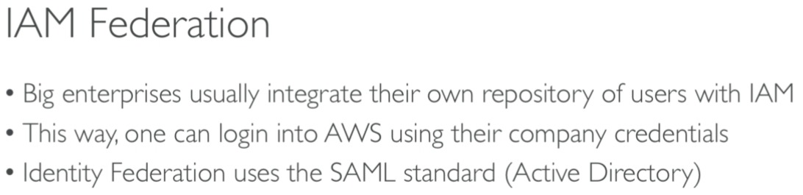

* IAM federation is used to create the users with the company ID for bigger enterprises.

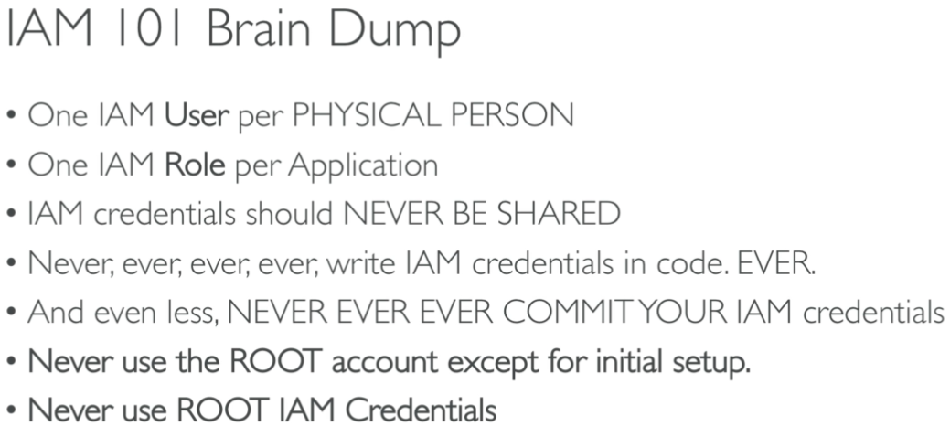

**IAM (Identity and Access Management service):**

* IAM is not a region-specific service. It’s a global service
* In IAM, we can restrict user to perform certain tasks only
* We create policies and assign to users
* Root account used for billing purpose etc.
* To create users, we need to go to IAM console.
* Add user, enter the username